**Impact of ICT on education in University of Sri Jayewardenepura**

**Introduction**

This Study is about the Impact of ICT on Education in Students of Sri Jayewardenepura University. World of ICT changes every day. Use of ICT creates an easy life for human beings. People adopt to new technology and change their life style a lot.

Same thing applies to the students of a University. ICT is now used inside university of Sri Jayewardenepura widely. University have its own LMS web site to support students in their learning process. Other than that University offers computer facility for the Students for their Studying purpose.

Therefore this research has been carried out to investigate the impact ICT makes on the Education of the Students in University of Sri Jayewardenepura.

**Justification / Rational of this project**

In present days education field has become more computerized. Students use online references and lecturers will use Web in order to provide notes to students. Which in old days took a lot of time and a lot of effort to do. By adapting to this new technology mind of students and Lecturers might have been changed. Some people may like this new way of teaching and some may not. Most of the institutes only use new technologies of educations. Some Students with low facilities finds it difficult to find notes then.

**Literature Review**

### **Overview of ICT in University of Sri Jayewardenepura**

University of Sri Jayewardenepura uses ICT for education purposes of the Students widely. Starting from the university Student registration every activity in the management of the University is now computerized.

University Library offers computer facility to the students who visit Library. University Library contains a Library Management System which supports Students in searching books easily and it allows students to read some of the pdf versions of the books.

University offers multiple Wi-Fi areas inside the university. It is always open and students are free to use it for their studying purposes.

Therefore University of Sri Jayewardenepura can be considered as a better place to learn with usage of new Technology.

### **Commonly Used ICT equipment among Students in the University**

From observation research group was able to identify that there are set of ICT equipment which University students use widely. Those equipment are as mentioned in the below list

* Computers/Laptops
* Tablets
* Phones / Smartphones

Almost every student of the University have at least one of these ICT equipment and they are attached to them.

### **Similar Research Details**

**Introduction**

Similar survey was carried out by Mbah in University of Beua, Cameroon. Two main purposes of this research was to investigate student familiarity and attitude towards ICT and Secondary, the impact of ICT on students study habits.

**Materials and Methods**

This study was based on survey research design. This research was carried out in two parts. First part of the study was to achieve answers for the research question students familiarity with ICT and how they use it. And second part was carried out to investigate gender impact of the students to the ICT usage.

**Research Findings**

* *What are the students’ attitudes towards information and communication technologies?*

Results have revealed that 81% of the examined students have positive attitude towards ICT. From gender impact it showed 91% of male students supported to this question results and 73% of female students supported. So It was clearly displayed that male students supported more than female students.

* *Do Students use ICT to support their Studies?*

Results revealed that 83% of students use ICT to support their Studies. And study habits improve with the wide use of Internet.

* *Do gender impact on the use of ICT?*

Research revealed that 93% of male students use ICT to support their Studies and only 73% of female students use ICT to support their Studies.

* *Does ICT impact students study habits?*

Research revealed that 83% of Students use ICT positively to facilitate their learning and secondly it revealed that 80% of students go internet to send emails and to find data for study/research. And 65% go internet to chat with friends.

**Conclusion of the research**

Students of the University of Buea have a positive attitude towards the use of ICT to support studies and facilitate learning. As such, they use computers and the internet on daily basis to communicate through e-mail and chat, and also for research/studying. ICT is considered to exploit the flexibility of training. The rhythm of study, the allocation of time and the availability of teachers can allow better articulation between private life/professional life (studies) as well as a better allocation of time between the various uses.

**Research Questions**

* What are the Students attitudes towards ICT?
* Do students use ICT to support their studies?
* Does ICT impact students Study habits?

**Project Objectives and Scope**

Scope: - University of Sri Jayewardenepura

Objectives:

* To Study new Technologies of Education
* To Gather Students ideas of this technology changes
* Analyze and generate a research report

**Conceptual Framework**

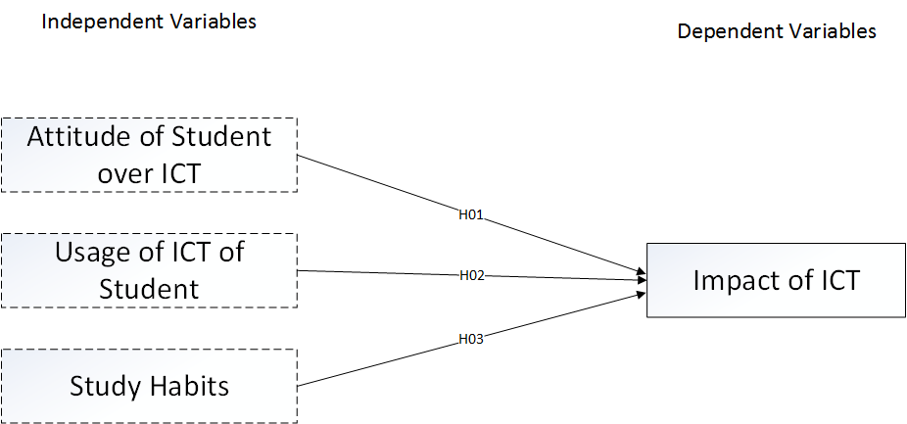

Figure 1 : Conceptual Framework

**Hypothesis Development**

**Attitude of Student over ICT**

Attitude means a settled way of thinking or feeling about someone or something, typically one that is reflected in a person's behavior. Therefore attitude of Student over ICT means the way of thinking of a student over ICT. What students think of students mean how likely they use ICT over their day to day work. Because of this attitude of students over ICT will affect the impact of ICT over students.

H01: Attitude of Student over ICT *significantly affect* impact of ICT on Student

**ICT usage of Student**

ICT usage means how much a person use ICT in their day to day work. More ICT a person use means more ICT will impact on the person’s behavior. Therefore ICT usage is related to Impact of ICT over Students

H02: ICT usage of Student *significantly affect* impact of ICT on Student

**Study Habits**

Habits mean a settled or regular tendency or practice. Study habit means a regular practice over studying methods. If a person have study habits which is based on ICT, it is understood as that Study habits will affect the impact of ICT over that person.

H03: Study Habits *significantly affect* impact of ICT on Student

### **Design and Study Sample**

#### **Population**

Population of the study will be the students of the University of Sri Jayewardenepura. Only undergraduate students will be included. This is a mixed faculty research so research did not divide into any faculty.

#### **Sample**

Sample of the study was fifty students from canteens in the University of Sri Jayewardenepura.

**Data Collection**

Questionnaire and Observation method will be used to collect data for the research. 50 questionnaires were provided to students in the university.

For research through observation research group managed to get in and blend with the students in the university.

**Research Variables**

First three questions were used to collect respondents’ demographic information. Three questions were asked to take answers for first variable. Six questions were used to take respondents answers to second variables. Five questions were used to take respondent answers for third variable.

|  |  |  |  |
| --- | --- | --- | --- |
| Category | | No of Respondents | Percentage |
| Gender | Male | 22 | 44% |
| Female | 28 | 56% |
| Faculty | Management | 13 | 26% |
| Art | 10 | 20% |
| Home Science | 5 | 10% |
| Medical Science | 12 | 24% |
| Applied Science | 10 | 20% |
| Year of Study | First Year | 0 | 0% |
| Second Year | 18 | 36% |
| Third Year | 19 | 38% |
| Forth Year | 13 | 26% |

Table 1: The profile of respondents

**Data Analysis and Discussion**

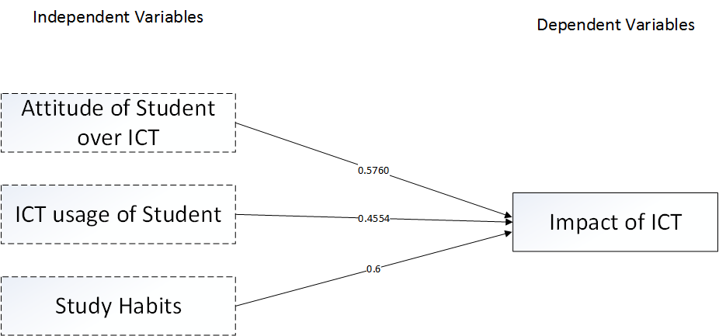

Figure 2: The Results of Proposed Research Structure

**Effect of Attitude over ICT for Impact of ICT**

The coefficient for Attitude of Students over ICT on Impact of ICT is 0.5760. This mean students of the University have a good attitude over the ICT. By having a positive value it indicate that Attitude of Students over ICT is positively connected with the Impact of ICT in the Education field of the University. It means that increase of Attitude will result in increasing the impact of ICT does on Education field. On the contrary decrease of the attitude will result in deceasing the Impact of the ICT on education field. So from analysis this indicate that universities should increase the attitude of the students to increase the Impact ICT does on Education of the students.

**Effect of ICT usage for Impact of ICT**

The coefficient of the ICT usage for Impact of ICT in education field is 0.4554. This means students in University have a good usage of ICT in their education. Positive value of the coefficient means that ICT usage of student positively connects with impact of ICT on the education field. Therefore increasing the usage of ICT of a student will result in increasing the impact of ICT does on the education of the student. On the contrary decreasing the ICT usage will result in decreasing the impact. Therefore University of Sri Jayewardenepura should increase the ICT usage more to have more good impact of ICT on the education.

**Effect of Study Habits for Impact of ICT**

The coefficient of Study habits for impact of ICT is 0.6000. This means students in the University have their study habits aligned with ICT. They use ICT for their study daily. Positive value means that increasing the study habits of using ICT will result in increasing the impact of ICT doing on education. On the contrary decreasing of the study habits of students using ICT will result in decreasing the Impact ICT does on education. As results of analysis University should try to Increase the study habits involving ICT of a student to Increase the Impact ICT does on students education.

**Summary**

* Students of University of Sri Jayewardenepura have a good attitude for ICT in the education field. This was concluded because correlation coefficient is 0.5760.
* Students of University of Sri Jayewardenepura have a good usage if ICT equipment to aid their Education. This was concluded because correlation coefficient of ICT usage over Impact ICT does on education is 0.4554.
* Students of University of Sri Jayewardenepura have study habits involved with ICT on their education. This result was concluded using the correlation coefficient of Study habits over Impact of ICT on education. Value was 0.6000.
* To increase the Impact of Education and make students learn more faster using ICT, University should encourage and make a good attitude of ICT over students and also, University should try to increase the ICT usage of Students. Making students add ICT usage to their study habits will result in good education for students

**Conclusion**

This study successfully identified that Attitude for ICT, ICT usage, Study habits of students in the university directly affect the impact of ICT on the education of student. And also it identified that students in the university have a good attitude towards ICT, students use ICT for their education purposes and they have included using ICT for their Study habits. This defines that the Impact of ICT in University students’ education is high.

By adding more value to these three Variables University can increase the education level of students very well using ICT.

To do this University should organize some programs which would change students attitude from bad to good of using ICT in their education.

University should provide students with more ICT space like Wi-Fi areas, more computers for public use inside the University.

University should encourage students to use ICT tools when doing their assignments and referring lecture notes.

**Future suggestions for research**

This study was carried on a very basic level. For this only three variables were used. This research can be more deeply done by inserting following to the research:

* Is there a relationship between gender and Impact of ICT?
* Increase number of universities taken
* Increase the sample size of each university
* Add interviews in the data collection phase to collect more data

**References**

Anon., n.d. Perfomance and Evolution Service. [Online]   
Available at: http://pes.sjp.ac.lk/  
[Accessed 19 01 2015].

Anon., n.d. University of Sr Jayawardenapura. [Online]   
Available at: http://www.sjp.ac.lk/  
[Accessed 16 01 2015].

Mbah, T. B., 2010. The Impact of ICT on Students' Study Habits.Case Study: University of Buea. p. 4.

Abdulla Y, Al-Hawaj Wajeeh Elali, Twizell EH (Ed) (2008). Higher Education in the 21stCentury: Issues and Challenges. Taylor &Francis Group, London, UK.

Bataineh RF, Baniabdelrahman AA (2005). Jordanian EFL students’perceptions of their computer literacy, International J. Educ. Develop.using Infor. Comm. Technol., (IJEDICT), 2(2), 35-50.

GARRISON DR, Kanuka H (2004). Blended learning: Uncovering itstransformative potential in higher education. Internet and HigherEducation, 7.

Liu Z (2005). Reading Behaviour in the digital environment: changes inReading behaviour over the past 10 years. J. Doc., 61 (6): 700-12

Morahan-Martin J (1999). Women and Internet: promise and perils.Cyber Psychology and Behavior, 3(5), 683–696. Morgan, C.T., 1956.An introduction to Psychology. McGraw-Hill Book Co., Inc. N.Y.,USA.

Ramirez E (2003). The impact of the Internet on the reading practices ofa university community: the case of UNAM", Proceedings of the 69th IFLA General Conference and Council, available at:http://www.ifla.org/IV/ifla69/papers/019e-Ramirez.pdf

Schumacher P, MorahanMartin, J (2001). Gender, internet andcomputer attitudes and Experience, Comput. Human Behav., 17(1),95-110

Shashaani L (1997). Gender differences in computer attitudes and useamong college students, J.Educ. Res. Comp. Res., 16, 37-51.